Accessibility Guide for The George and Dragon
reception@gdhotel-yorkshire.co.uk, 01751433334, www.gdhotel-yorkshire.co.uk
Contact for accessibility enquiries: Laura Moore
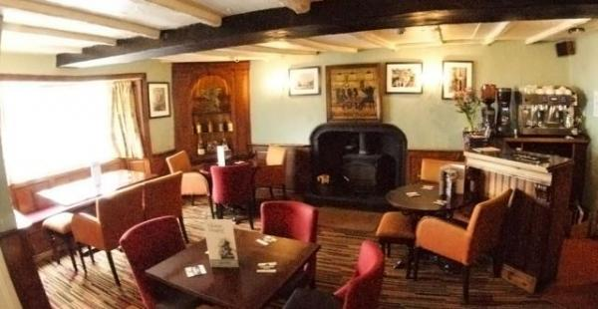

Welcome
The George and Dragon is a traditional 16th century coaching inn offering the perfect rural retreat. Think fuss free relaxation; real Yorkshire hospitality, cosy corners, log burning stove and sumptuous restaurant. We encourage you to really put your feet up and relax. Just like home, only better.
Whether you are looking for a romantic getaway in our Garden Suite, a walking/ biking based visit with friends, a big family room to take the kids to Flamingo Land or just to have drinks and dine in our restaurant, a warm and friendly Yorkshire welcome awaits you all of our team.

At a Glance

Level Access
- The main entrance has level access with a ramp. The ramp is permanent.
- There is level access from the main entrance to:
  - Bar reception
  - Main bar
  - Bar/Bistro
  - Courtyard area
  - Rear of the hotel

Access with steps
- There are steps from the main entrance to:
  - Bedroom
  - Dining Table

Bedrooms
- We have non-allergic bedding.

Hearing
- The (bedroom) TVs have subtitles.
- Some staff have disability awareness training.

Visual
- The walls and the doors have high colour contrast.

General
- Some staff have disability awareness training.

Getting here
The George and Dragon Hotel
17 Maeket Place
kirkbymoorside
YO62 6AA

Travel by public transport
- You can get to The George and Dragon by bus.
- The bus stop in Kikrbymoorside is the Scarbrough to Helmsley route and run very regularly. There are regular buses to Malton where you are then on a main train line connection There are also buses to and from York, although these are less frequent. The bus stop is 0.1 miles / 0.2 km from The George and Dragon.
- You can get a taxi with Nigels Private hire by calling 01751432795.
- You can get a taxi with Moorside Private Hire by calling 07842640359.

Parking
- We have a car park. The parking is less than 50 metres from the main entrance. Parking is free.
- There is a drop-off point at the main entrance. The drop-off point has a dropped kerb.
- From the car park to the entrance, there is level access. There is a permanent ramp.
- The route is 2100mm wide, or more.

Arrival

Path to main entrance
- From the street to the main entrance, there is level access.
- There is a permanent ramp.
- The path is 2100mm wide, or more.

Main entrance
- The main entrance has level access.
- There is a permanent ramp.
- The main door is side hung and manual.
- The door is 2000mm wide.
- All of the above is based using the main entrance to the rear of the building. The front entrance has 3 steps and therefore not user friendly.

Getting around inside

Visual Impairment - General Information
- We have high colour contrast between walls and doorframes.

Bar reception
- From the main entrance to reception, there is level access. The door is 2000mm wide.
- You can sit down at reception.
- The reception is in the main bar area. We do not have an official recption desk, we simply give guests the form to fill in wherever is comfortable for them.

Bedrooms
- All bedrooms have windows.
- Bedrooms have ceiling lights, wall lights, floor standing lights, bedside lamps and natural daylight.
- Lights are fluorescent tube, halogen and energy saving. TVs have subtitles.
- All bedrooms are non-smoking.
- We have non-allergic bedding.
- All bedrooms have fitted carpets.
- We have wi-fi free bedrooms, for visitors with electro-sensitivity.
- At the time of booking please let us know of any allergies. We also have some bedrooms that we do not allow pets and therefore these would be most suitable for any allergies or asthma.
- We can move the bedroom furniture, to improve accessibility.
- No bedrooms have level access. The bedroom nearest the main entrance has 1 steps.
- All bedrooms are ensuite.
- We have bathrooms with a separate shower.
- We have bathrooms with a bath and overhead shower. We have bathrooms with a bath.

Bar

Main bar
- From the main entrance to the bar, there is level access. The route is 900mm wide, or more.

Place to eat and drink

Restaurant
- From the main entrance to the dining area, there is level access. The route is 800mm wide, or more. The door is 800mm wide.
- To get to a table, there are 3steps steps.
- There is background music.
- We cater for sugar free (diabetic), vegetarian, gluten free (celiacs), lactose free (dairy free), nut free, low fat, low potassium, low sodium, high fibre and vegan specific diets.
- All of our food is made fresh to order in our own kitchens. We can tailor any of our dishes to meet various dietary requirements.
Although we do not have the menus in other forms availabke to hand, a member of the team would be very willing amnd happy to read out any menu choices.

Bar/Bistro
- From the main entrance to this area, there is level access. The route is 1500mm wide, or more.

Getting around outside

Courtyard area
- From the main entrance to the gardens, there is level access.
- There is a permanent ramp.
- The route is 900mm wide, or more.

Smoking

Rear of the hotel
- From the main entrance to the smoking area, there is level access. There is a permanent ramp. The route is 900mm wide, or more.
- The entrance is 900mm wide.
- The smoking area has a shelter.

Customer care support

Accessibility equipment
- Assistance dogs are more than welcome to use our main bar toilet.

Customer care support
- Some staff have disability awareness training.
Guide last updated: 12 February 2019

